**CHAPTER 5**

**FURNACE MACHINE MONITOR AND CONTROLLING ARCHITECTURE FOR FOIUNDRY ON INDUSTRIAL 4.0 USING IoT**

The automotive industry is one particular sector of the market that is rapidly expanding and has enormous economic significance. Automobile sector involves the production of various types of vehicles, including cars, trucks, motorcycles, and commercial vehicles. Major automobile manufacturers have assembly plants around the world, where vehicles are manufactured using advanced production techniques and technologies. The automobile industry is a segment of the market that is extensively regulated by rules and specifications due to the complexity of the manufacturing processes. Foundries play a crucial role in the automobile industry by providing cast metal components that are used in the manufacturing of vehicles. Foundries work with a wide range of metals and alloys to produce automotive castings components can include engine blocks, cylinder heads, transmission housings, brake calipers, suspension parts, and other critical components. Automotive industries will generally work to increase customer loyalty and quality over time. The majority of successful auto manufacturers will, in general, continue to develop their products and make improvements. The heat treatment method helps to make the metal parts stronger, which is necessary for all automotive components to be robust and lightweight.

* 1. **OVER VIEW OF HEAT TREATMENT FURNACE (HTF)**

Heat treatment plays an important part in the foundry industry, specifically in the post-casting processing of metal components. To improve the castings performance and mechanical properties, it involves gradually heating and cooling them. The function of heat treatment in foundries is described in more detail as follows

1. **STRESS RELIEF**

Internal stresses within the metal components can be introduced during casting processes as a result of uneven cooling and solidification. These continuous stresses are reduced with the support of heat treatment, specifically stress relief. Castings are heated to a particular temperature and are then maintained there for a specified amount of time.

1. **ALTERATION AND MECHANICAL PROPERTIES**

In this process can modify the mechanical properties of casting to reach the specific requirements, this have multiple standard process like quenching, tempering and annealing are used to change the hardness, strength, toughness and ductility.

1. **STRUCTURAL TRANSFORMATION**

Heat treatment the handling structural transformation output that change the microstructure without changing dimension.

1. **HARDENING AND DIMENSIONAL STABILITY**

Castings dimensional stability can be controlled with the help of heat treatment. It reduces the effects of dimensional changes caused on by factors including heating and cooling during casting. Heat treatment can decrease the possibility of bending or distortion, ensuring that the final components maintain to the necessary dimensional tolerances.

1. **REDUCE THE CASTING DEFECTIVES**

Many casting defects may be eliminated or reduced with the help of heat treatment. For instance, heat treatment can help in polishing up the casting and increase cleanliness while also improving the grain structure. Hydrogen gas that could become trapped inside the casting during the solidification process can also be removed with its support.

Heat the metal slowly and gradually, maintaining a constant temperature. The temperature from the temperature controller with the set value was continuously monitored by the time-temperature control process. Four separate temperatures have been measured from the furnace: the left, right, top, and bottom temperatures are continuously monitored for quality purposes and for customer feedback. The procedure runs continuously from 12 hours to 70 hours, and during this time the temperature must remain at a specific level. According to the product and the procedure, two different temperatures must be held twice in a single operation. During each holding period, the temperature is practically maintained for up to three to four hours, but the metal is never heated to the point of melting.

1. Heat raising stage
2. Shocking/ holding stage
3. Cooling stage

The iron material gradually warms up during this stage. As the temperature rises, the metal's exterior molecules mix and help the metal's outer surface material become stronger throughout the gradual rise from room temperature to above 500 degrees. The temperature should gradually increase throughout the stage, if it increases unevenly or more quickly than expected, the output result of the casting will be warped or cracked.

The substance is held at a specific temperature for a specified amount of time during the holding or soaking stage. In the heating step, the material's outer layer becomes hard in the holding phase, the surface changes and by maintaining the temperature for a prolonged amount of time, the homogenous molecular inside of the surface material became stronger. This holding period is dependent upon the type of material and the size of the substance the longer the holding time, the larger the material,

In the process of heat treatment, cooling pace is particularly crucial because quick cooling changes the molecular structure of high-temperature metal parts, increasing their hardness.

* 1. **THE FUNCTION OF HEAT TREATMENT**

The heat treatment procedure has been established for more than a century and is still in use today the heat treatment process is required in many industries, including the automotive and transportation sectors, the railroad industry, the aerospace industry, the building and construction industry, and numerous home appliances. Some metals are soft therefore, heat treating them causes them to become harder, and the heat-treating procedure aids in hardening the material without altering its shape not only the hardening, it makes the casting compressive strength, elasticity, improve the hardness of the metal, reliving the internal stress, change the chemical composition like silicon, carbon, manganese, copper, tin, zin, magnesium, pearlite and cementite

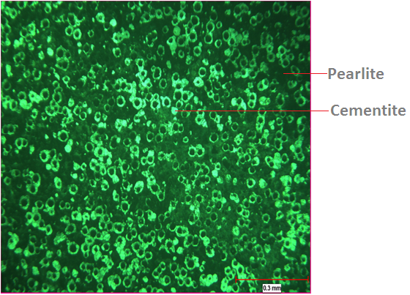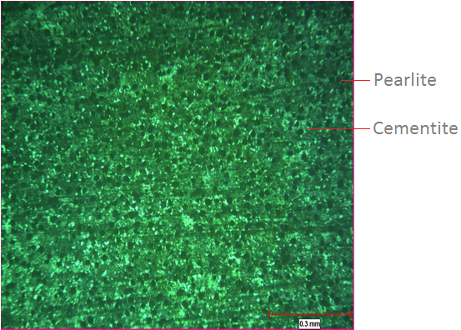

Fig1. Before heat treatment micro structure Fig2.After heat treatment micro structure

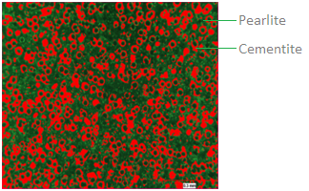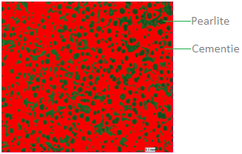

**Fig3. Correct Micro Structure after heat treatment Fig4. Bad micro structure after heat treatment**

Before heat treatment, the casting part's cementite and pearlite have a gap, as shown in Fig. 1. A low-hardness image of the processes of annealing, stress-relieving, and normalizing, each of which has to keep the temperature at a specific level, depends on the mechanical properties of the metal.

Each component needs to undergo heat treatment, which is dependent on the characteristics of the metal, following the heat treatment procedure, cementite and pearlite molecular structures link together and strengthen the metal component.

* 1. **CHALLENGES IN HTF MONITORING SYSTEM AND REQUIRES INDUSTRIAL 4.0**

The future is presently being shaped by quick IoT research. The factory needs to digitize and progress towards upgrading to "Industry 4.0" for better control over processes. increased use of energy the outdated system is controlled by a PLC however, the majority of PLCs and controllers don't communicate with the internet or cloud. With regard to their specialized software, circuitry, and cables, they are of varying quality., Lack of visibility for configuration changes, manual data logging, and absence of root cause analysis for monitoring, a traditional system should be physically present anyone can alter the parameter.

More smoke and a hotter environment are brought on by the heat treatment furnace, due to this the workers in foundries are exposed to a variety of harmful compounds, which is a significant risk to their health.

Heat treatment processes require a lot of power to run some of them can last for up to three days without a break and occasionally use the power of an entire village.

The temperature is monitored and controlled since the furnace environment is practically an extremely high temperature area (about 160 C). In order for automotive parts to maintain proper heat flow and become strong, the heat treatment process is essential. The metal part of the automobile will acquire toughness through this heat treatment technique. To sustain the complex process in the foundry environment, manual operation is more thorough.

* 1. **Risk factor and need of automation in heat treatment**

According to the National Highway Traffic Safety Administration (NHTSA), if any accident is caused by defective parts and it is proven, then the main accident only occurred due to human error, defective parts, and mechanical flaws. A manufacturer complaint may be made by the vehicle's owner. In order to fix the damaged car, the manufacturer must recall it. and they should examine all the vehicles that were produced at the time. It's vital to note that customers should not be charged for replacing a vehicle because doing so would be more expensive for the manufacturer.

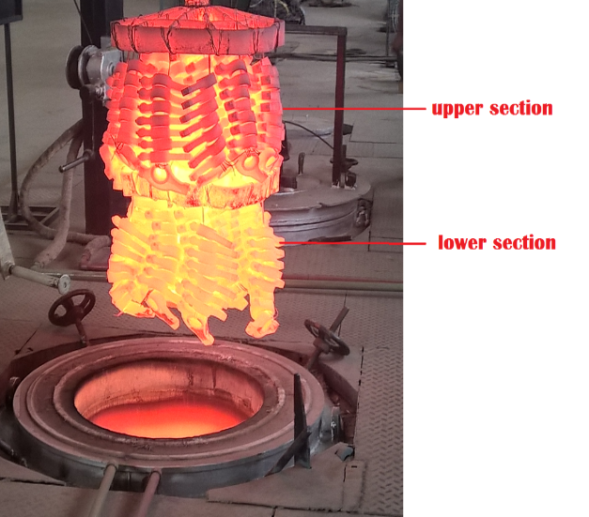

Fig: Temperature difference top & bottom layer,

* 1. **INCORRECT HEAT TREATMENT ORIGIN**

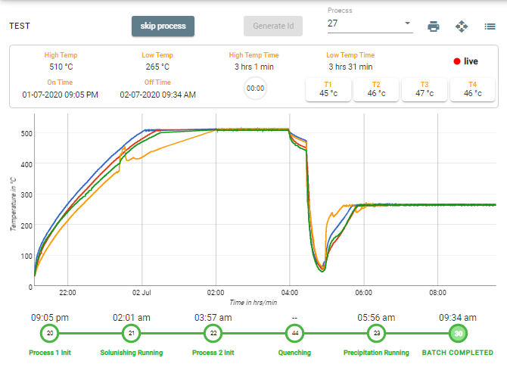

Fig: Temperature difference graph view

The photograph and digital graph both demonstrate how the temperature is heavily variable and lower on the top side than the bottom.

* 1. **MAJOR ISSUE FACING IN HEAT TREATMENT PROCESS**

In the Heattratment process, problems with the furnace overheating, people's ability to maintain the process, analogue measurements, and power consumption exist. If any one of the temperatures is too low, the side coil, which is the weakest component, will run continually and use more power.

* + 1. **PEOPLE MANAGEMENT**

The standard operating procedure for the heat treatment process. Every casting part must be maintained at a specific time and temperature according to the manager's instructions, and the operator must follow these instructions while the supervisor checks the operation., The operator must record and monitor the temperature every hour, and they must also be trained. A heat treatment operator will control the

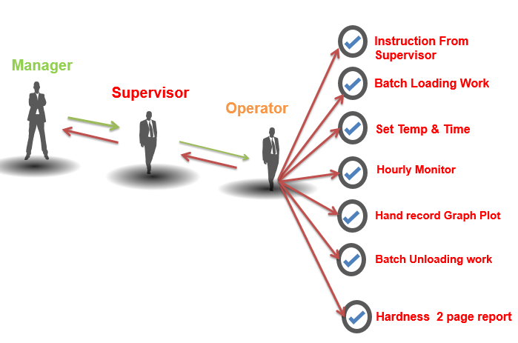

Fig: Manual instruction process flow

temperature and the timing. Additionally, the operator will switch shifts during the roughly one to two days that the furnace is in operation, so he or she won't be on the field during break and changeover times. If the settings for the time and temperature are correct, the damaged product will make it more difficult to locate if there is an issue with the temperature and time settings.

* 1. **QUALITY CHECKING PROCESS**

Regarding quality across all businesses and organizations, the customer specification requirement (CSR) will be checked as part of the quality inspection system, and CSR will vary depending on the product. The casting's four corner edges (left, right, top, and bottom) will be inspected after heat treatment. The four-corner edge of the heat-treated casting rack is shown in the figure.

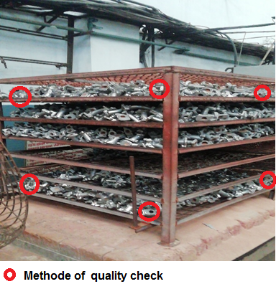

Fig: Automobile part quality inspection selection POINT

Each and every product amount is stated in the quality system as not being included in the quality check. The quality standard is that 1 to 10 pieces will be sent for quality inspection in a bundle or batch. Major vehicle parts are just a few of the quality-checking inspector's fine shortcuts for moving quickly.

* 1. **MANUAL CONTROLS**

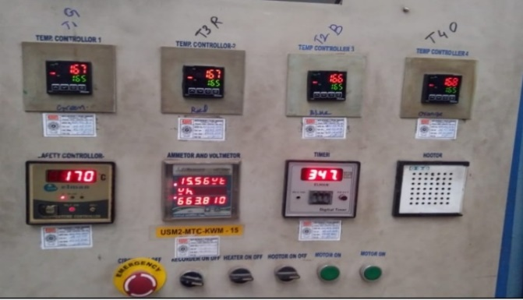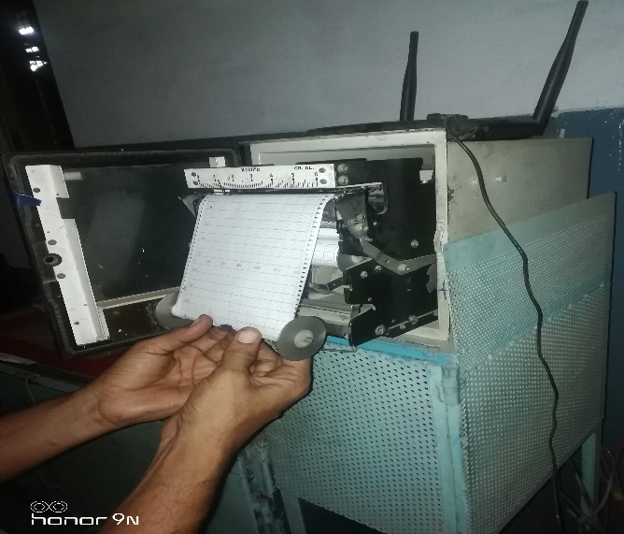

Fig: Manual control and analog graph chart

The furnace operator simply sets the specific time and temperature in addition, he must confirm that the temperature is held, is at the proper level on the top, bottom, left, and right, and is at the precise time and temperature that was set. A minimum of 6 hours and a maximum of 2 days are needed to finish this operation. In addition, currently operating components of the microstructure become uneven, and the process uses 250 to 500 units per day if any errors are made.

* 1. **ANALOG MEASUREMENT**

The four temperatures were automatically read by the analogue graph recorder in the prior method's heat treatment graph recorder, which is analogue in type, and a graph was automatically plotted. In this procedure, the graph record is used more frequently to plot theses, and the heated environment also damages the recorder. If an error is found in a previously completed record, we are unable to analyses or verify it in thesis form, and the operator is then free to construct a false record. Any errors he made during the process will be revealed. The audit of the heat treatment area is more difficult at the time of the yearly audit since it includes a complete thesis-formatted one-year graph record.

The proposed approach is difficult to implement and requires a year of competition as well as additional research cases.

* 1. **ONLINE HEAT-TREATMENT MONITORING AND CONTROLLING ARCHITECTURE**

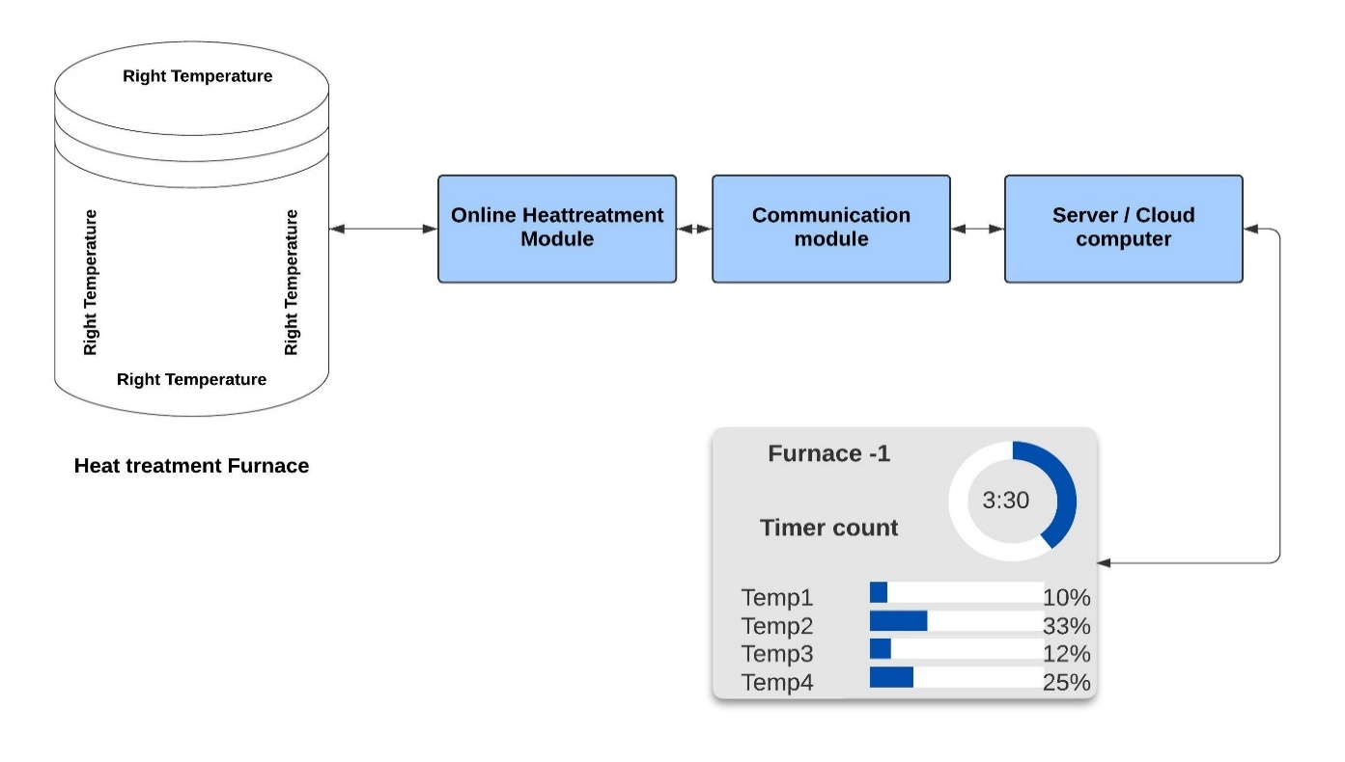Fig: Over view of OHMCS system

A factory that needs to digitize and move toward upgrading and industrial 4.0 in order to gain better control over the process and improve energy utilization. system can record the right, left, top, and bottom individual temperature graphs and view the furnace's live temperature for each machine. Each cycle of a process can be recorded so that the prior cycle can be seen. Each particular item or product's cycle can be customized in addition to monitoring and setting the preset value on a mobile device or computer, this method also tracks energy usage for each cycle to determine power consumption may save energy by tracking and comparing each cycle, and has the option of storing one day's worth of data in local eeprom memory if the cloud network or internet are unavailable. The report's maintenance is simpler.

The hardware module connected to the temperature controller via RS485 and send the requests to four temperature controllers directly connected to hardware RS485 communication to obtain the current temperature.

The XMC4700 Arm Cortex-M4 industrial standard microcontroller that was used in this system has a Class C rating and was created to prevent unique threats like controlled equipment exploding. Example burner controls that are automatic, a dryer that is controlled by gas in extreme temperatures, this standard controller can tolerate temperature ranges of up to 125 degrees C. Moreover, this controller features virtual engineering for digital applications (DAVE). A graphical user interface is used to set up apps., Automatic code generation is another feature of DAVE, and the produced code can be instantly compiled, debugged, and shown. This system was created to monitor the heat treatment furnace machine, which was used to measure the furnace's temperature. The XMC4700 microcontroller logically controls and processes the temperature data that was acquired Additionally, this XMC4700 board has Wi-Fi so that it may send the temperature data that has been recorded as well as receive temperature and holding time settings.

* + 1. **PERIPHERAL CIRCUIT INSIDE IN CCMA**
    2. **XMC4700 MICROCONTROLLER**

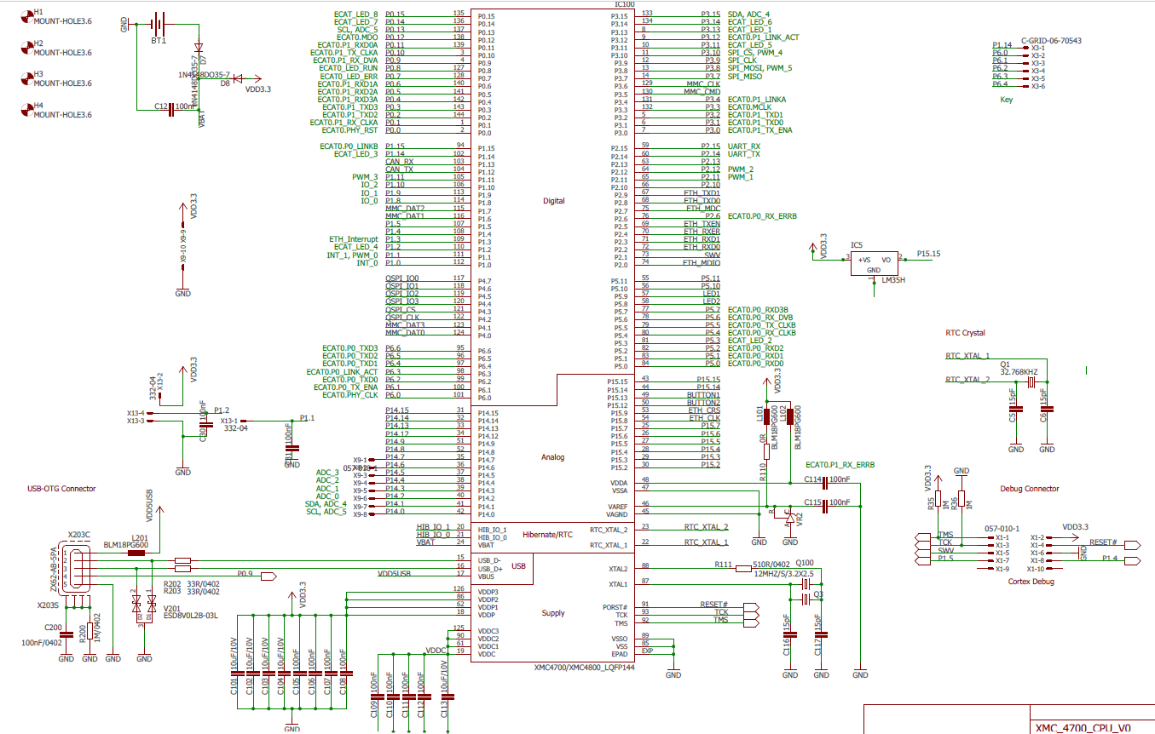

* + 1. **RS485 MODBUS COMMUNICATION SYSTEM**

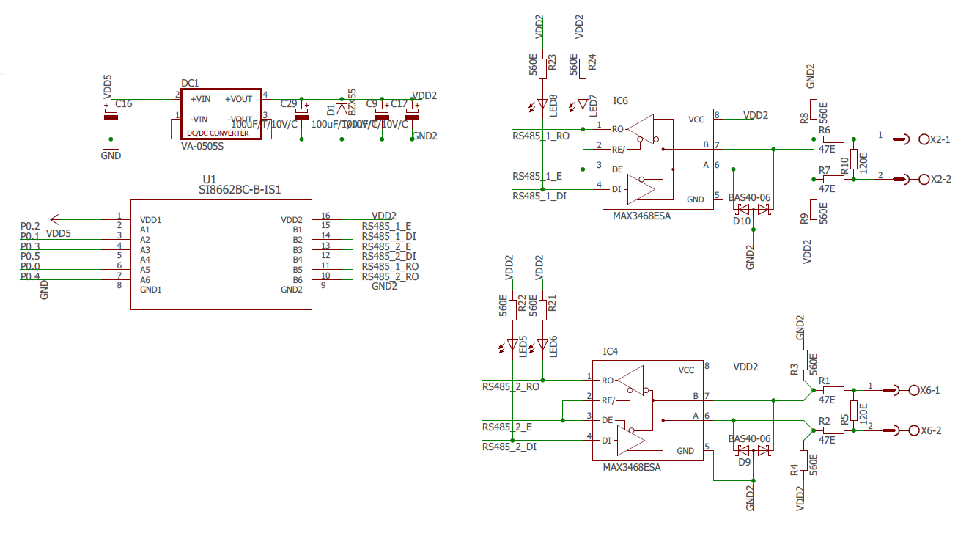

* + 1. **FLASH MEMORY FOR LOCAL SYORAGE**

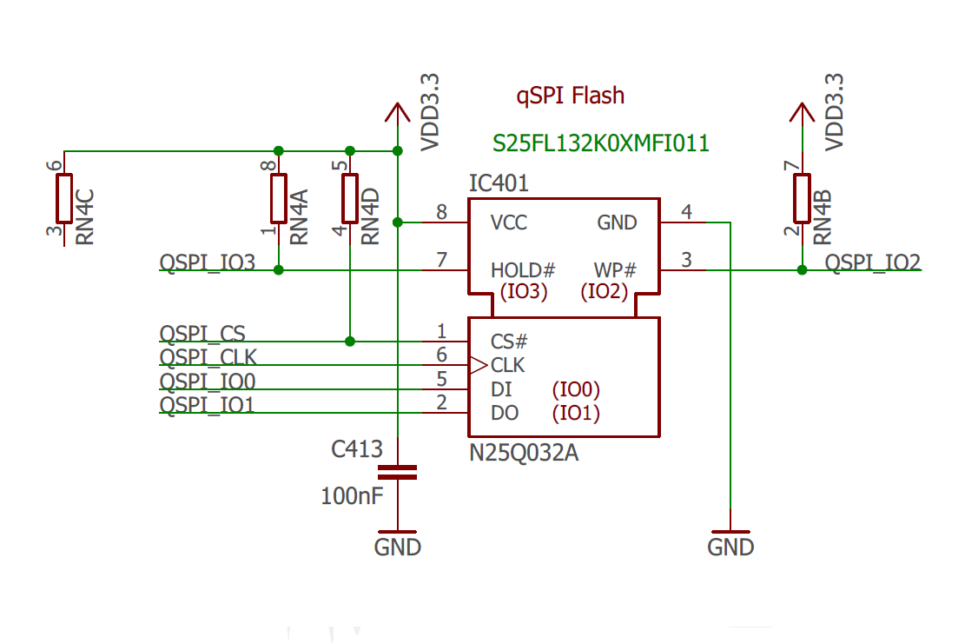

* + 1. **WATCHDOG**

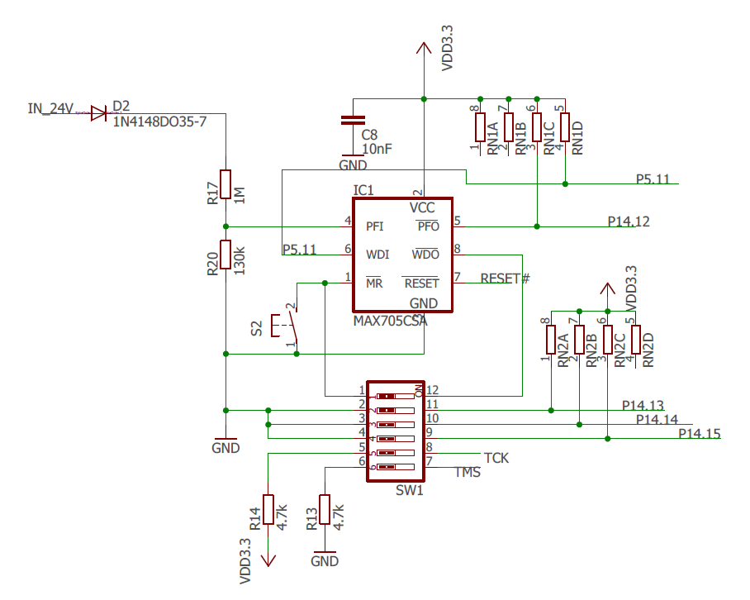

* + 1. **Wi-Fi COMMUNICATION MODULE**

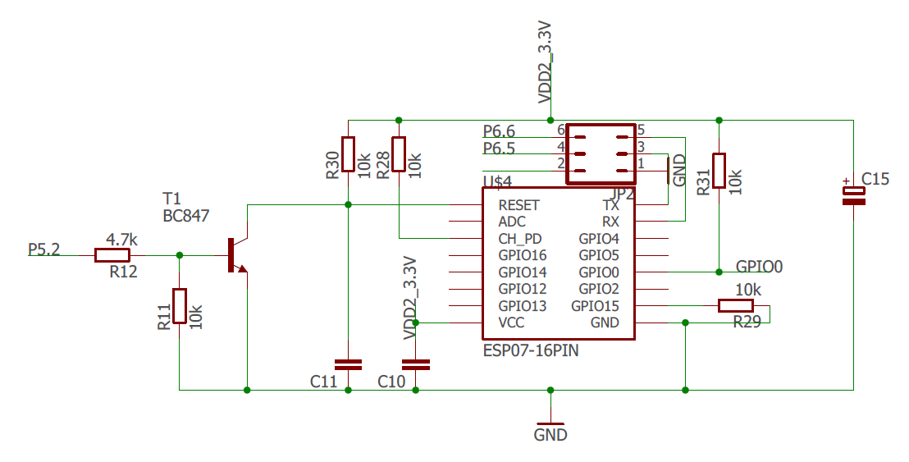

* + 1. **USER DISPLAY AND KEYPAD**

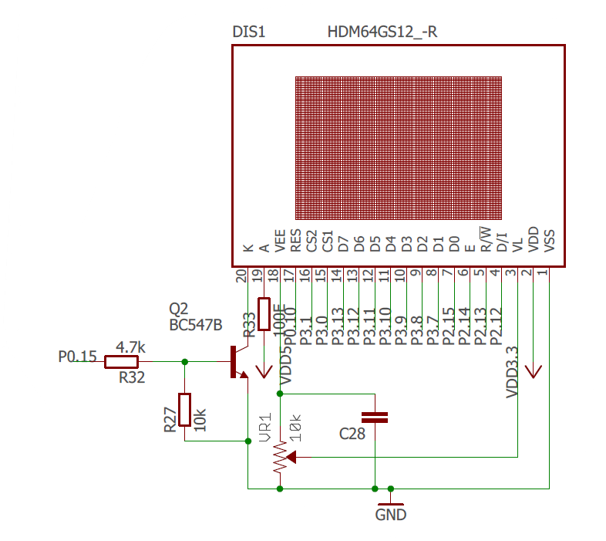

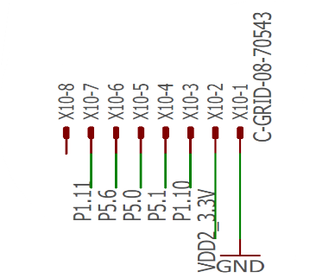

* + 1. **Data sync from Temperature controller to OHMCS**
    2. **Data collecting between device and furnace.**

Top, bottom, left, and right of the furnace Four sides of the temperature are measured by four independent temperature controllers, and RS485 is used to collect the data from the temperature controllers Modbus communication is used throughout operation, and the XMC4700 microcontroller controls and maintains the temperature set points and holding times.

Via RS485 to connect with the temperature controller using the Modbus protocol at a 9600 baud rate, the XMC4700 carries four temperatures from the temperature controller and reads their values in less than 200 microseconds Four temperature controllers can communicate within 800 milliseconds as a result. This RS485 circuit uses a TVS diode, an ADUM1201 insulator, a DC-to-DC converter, and a power source to shield the finished product from industrial noise. The use of the RS485 serial communications standard was made possible by the balanced data transmission method, which provides strong noise rejection and can drive reasonably long communications lines at relatively high data rates. The four temperature controllers' data are sent and received by the XMC7400 board's 485 communications in this prototype design in less than one second, as illustrated in the figure.

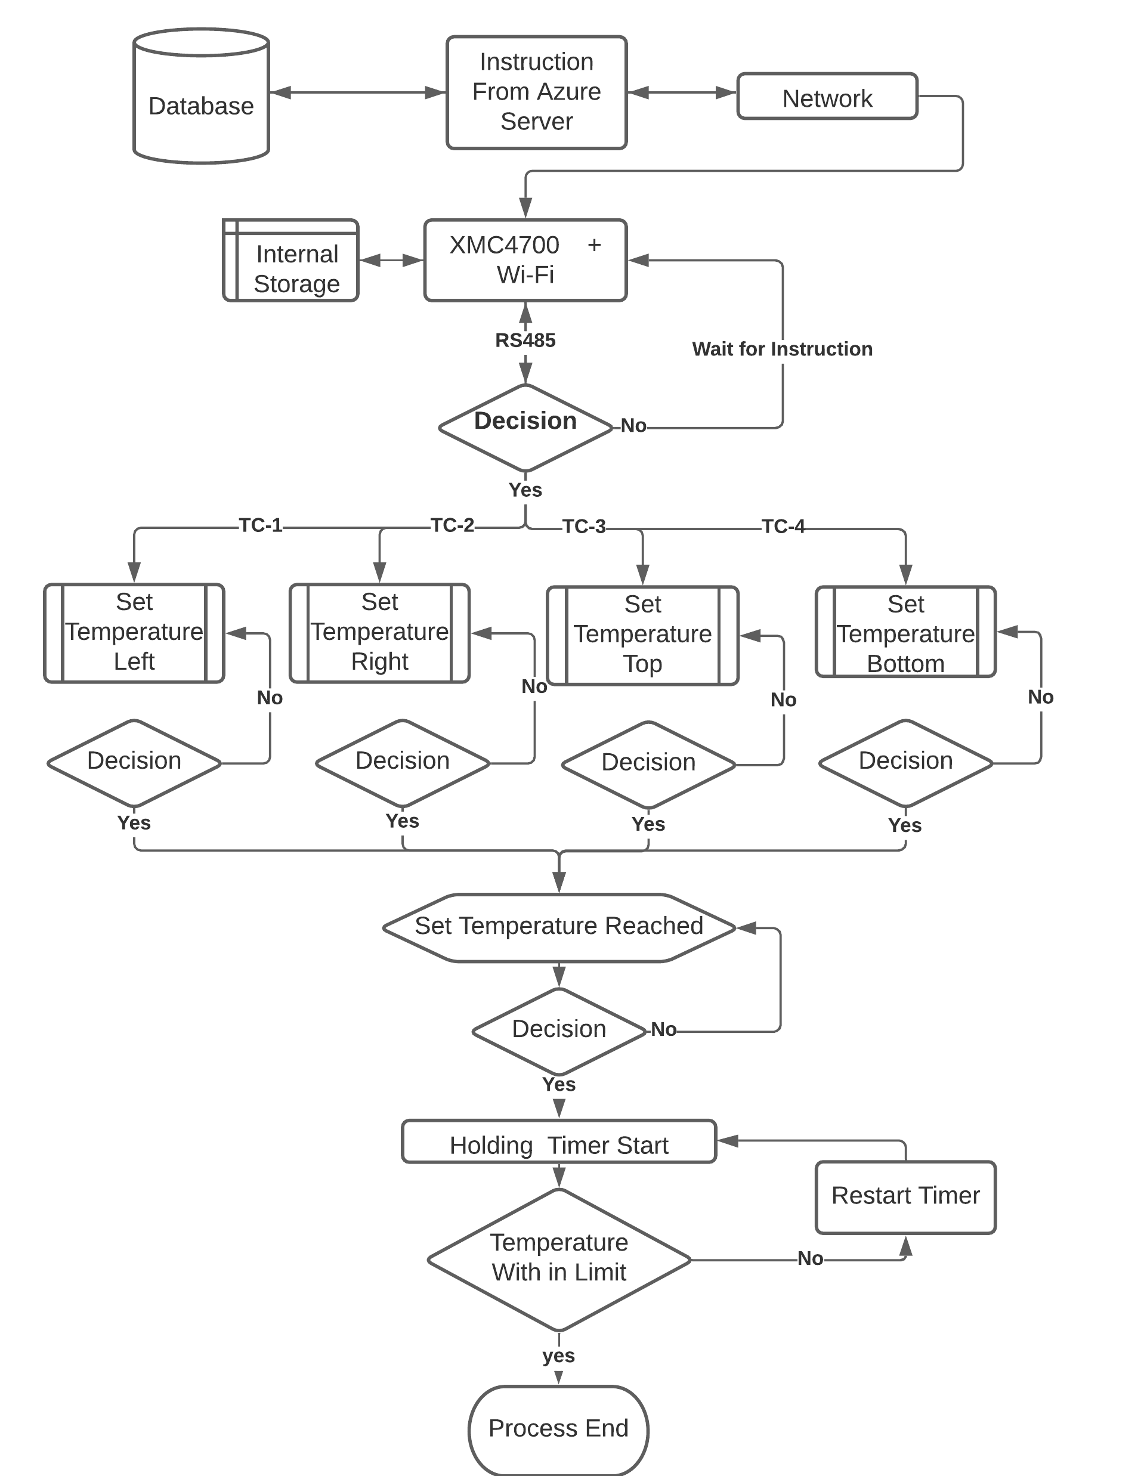

Fig: Logic flow of OHMCS system

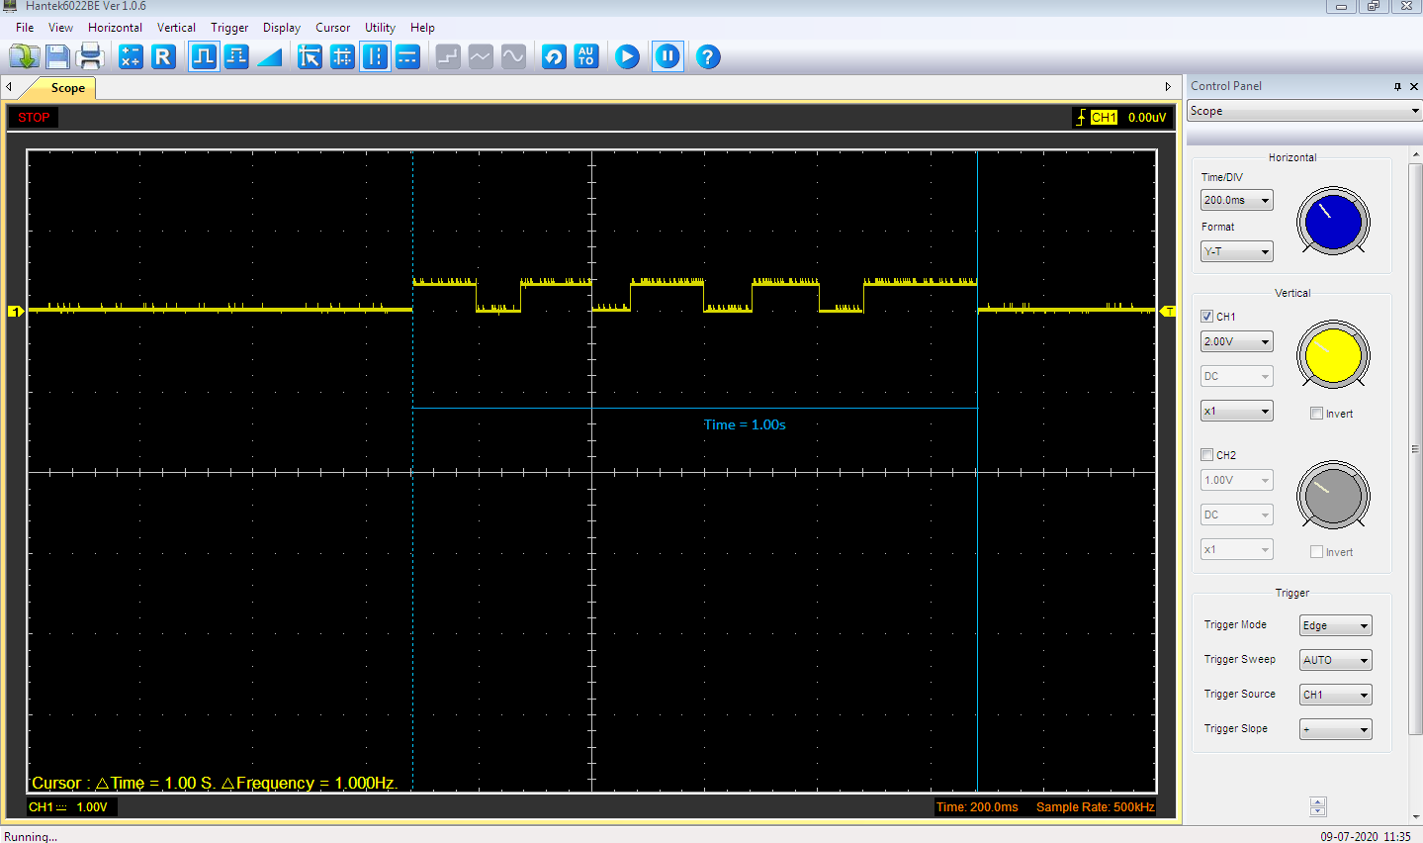

Fig: data communication between XMC4700 board and temperature controller.

The rs485 communication between the four temperature controllers at the top, bottom, left, and right is completed in less than 400 milliseconds, as seen in the following graph. depicts the connection between a single temperature controller.

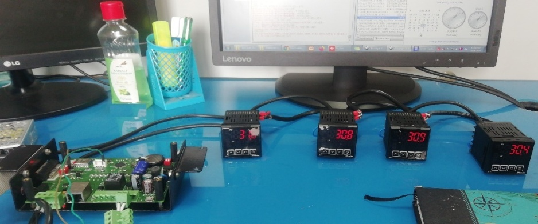

Fig: OHMCS connected with four temperature controllers

|  |  |  |  |
| --- | --- | --- | --- |
| S. No | Description | XMC Board (Request HEX) | Temperature controller Response (HEX) |
| 1 | To Read Temperature | 01 03 01 00 00 01 85 F6 | 01 03 02 00 20 B9 9C |
| 2 | To Set Temperature | 01 06 00 01 01 2D 19 87 | 01 06 00 01 01 2D 19 87 |

Fig: OHMCS connected with four temperature controllers

In the temperature communication system, in which the temperature controller is the slave and the OHMCS board is the master, the OHMCS board asks the sequence slave address and requests for the protocols at intervals of 100 MS.

|  |  |  |
| --- | --- | --- |
| Slave add | | 01 Hex |
| Function code | | 04 Hex |
| Register | MSb | 00Hex |
| LSB | 03 Hex |
| No of reg | MSb | 00 Hex |
| LSB | 02 Hex |
| CRC | MSb | 81 Hex |
| LSB | CB Hex |

Fig: Request for from the OHMCS

At the time of 100ms interval the as the request of the salve id OHMCS got response from the requested temperature controller in the intervals of 100

|  |  |  |
| --- | --- | --- |
| Slave add | | 05 H |
| Function code | | 04 H |
| no of byte | | 04 H |
|  |
| Data (weight) | MSb | 00 H |  |
|  | 00 H |  |
|  | 75 H |  |
| LSB | 1c H |  |
| CRC | MSb | 99 H |  |
|  | LSB | 1D H |  |
|  |  |  |  |

Fig: Temperature controller Response (HEX)

* + 1. **Data communication between device and server system**

Due to wireless software frequency configuration, unreachable locations behind walls or buildings, or mountainous terrain, wireless network planning is quite simple compared to wired network planning. This proposed solution makes use of the embedded reduction instruction set of the ESP8266 Wi-Fi, which is simple to programme using a microcontroller. Through the use of an XMC device, the four temperature readings are collected. Using an esp8266, the collected data is uploaded to a server system periodically. If the temperature in the furnace changes abnormally, the board will be alerted, and the server system will also display a false alarm message.

Hypertext Transfer Protocol (HTTP) is used by the Esp8266 Wi-Fi, and it is a protocol-based method of requesting information from a server. Every 7 seconds, the XMC device acts as a client, sending the data it has collected to the server through Esp8266 Wi-Fi. When a client requests information about the furnace's temperature, the server collects that information and responds with the set temperature points. The collected temperature data are then stored in a separate database, where they can be analysed to forecast warnings, notifications, and emails, among other things are sent automatically in the event of any substantial changes in the furnace temperature conditions, including alarms. A cloud-based storage system has the advantage of large data storage capacity and is faster with IoT.

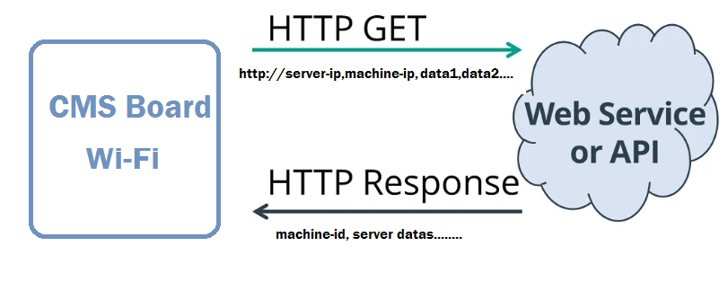

Fig: Diagram of HTTP Request and Response

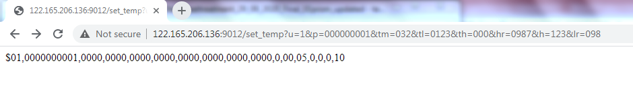

Fig: browser http request and response

In this proposed method, the furnace is controlled by a heat treatment application without the need for human involvement. This method focuses on continuous performance management, and it aids in the transition to a digital workplace where managers may oversee and control staff members through the system., Additionally, it provides greater security, brings the ideal machine, uses technology that quickly gathers machine data and provides feedback to help them improve the product, and takes a single-brain approach to process control and manual dependency into account that is capable of maintaining machine settings and controls in accordance with customer specifications.

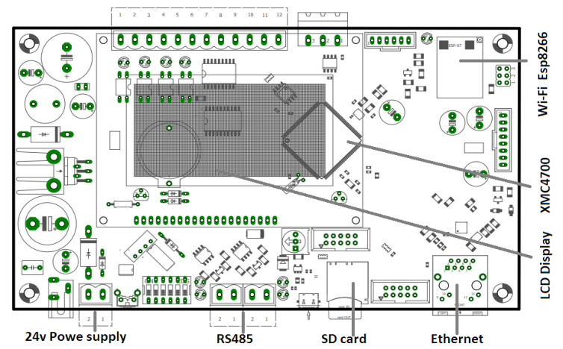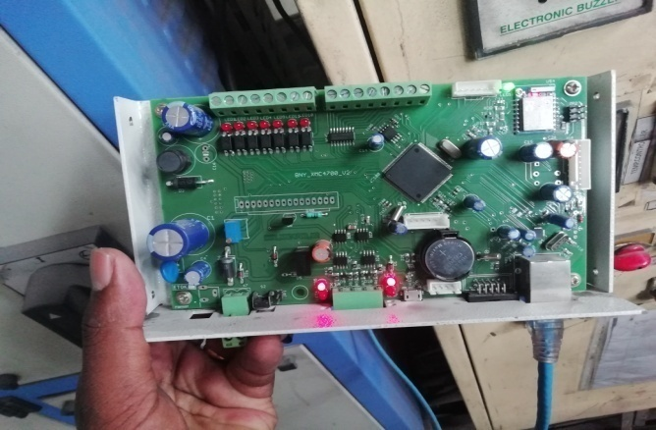

Fig: Shows the over view of Heat treatment process

* 1. **Summary**

In place of an analogue graph recorder and a manual control procedure, this proposed Internet of Things-based heat treatment prototype is being considered, This system is built to high industrial standards and can endure use in areas with high temperatures. Additionally, this system can continuously monitor the furnace temperature, and it uses Wi-Fi to communicate temperature data to the system application.

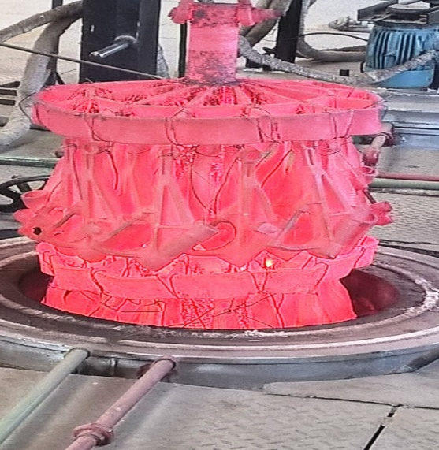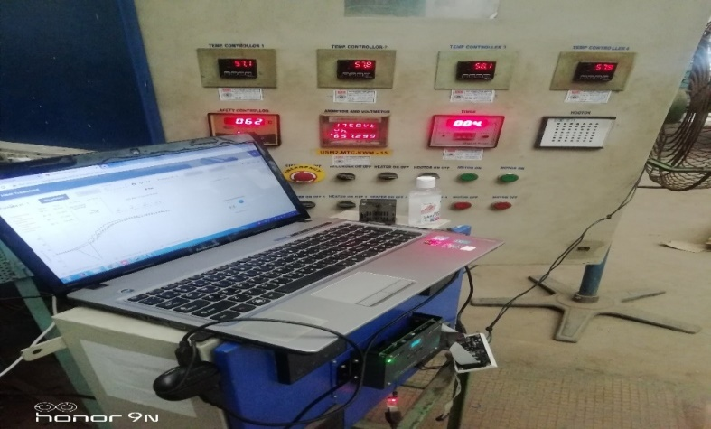

Fig: field tested on OHMCS

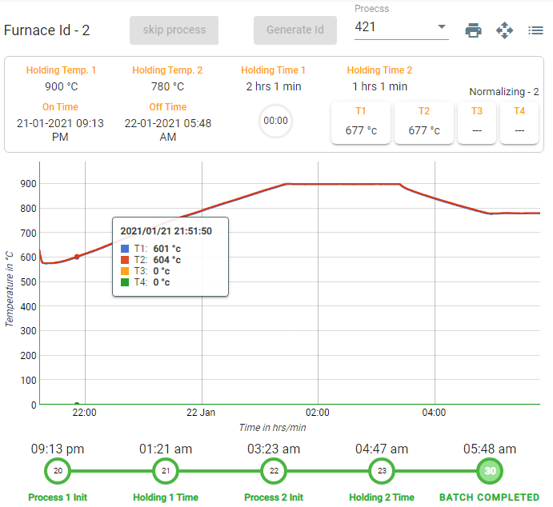

Figure: Software view of four temperature controller

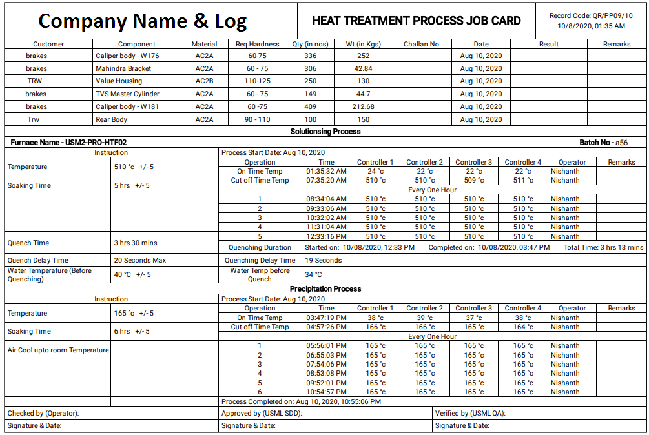

Fig: Final auto report replaced manual entry

* 1. **Conclusion.**

We carried out trials in three different scenarios to confirm the suggested system's correctness. In the first instance, we looked at the stability of the microcontrollers operating in the foundry environment., The connectivity between the board and the furnace temperature controller was scrutinized in the second instance. In the third instance, we looked at how a cloud server program, which controls and monitors the entire furnace, communicates with the board. Finally, we combine the three trials to create the suggested method, which aids in the plotting of the live furnace temperature graph, aids in the earlier detection of furnace temperature failure, lowers power usage, and improves product quality. and ultimately shown that industrial 4.0 can be applied to foundries.